Group name | EUROPE CLIENT - LVADV04-2026-EUR-8D7N-SAI GON-CU CHI-DALAT-PHAN RANG-NHA TRANG-BIKING | Code | 240919111752
Version | 1 | Sales consultant | Sale team
Group size | 2 - 6 pax(s) | Validity | 1 Jan 2026 – 31 Dec 2026

LVADV04-2026-EUR-8D7N-SAI GON-CU CHI-DALAT-PHAN RANG-NHA TRANG-BIKING
LVADV04-2026-EUR-8D7N-SAIGÓN–CU CHI–DALAT–PHAN RANG–NHA TRANG–CICLISMO
Day 1: Arrive Ho Chi Minh (Saigon) (-/-/-)
Arrive at Tan Son Nhat Airport and transfer to your hotel. The remainder of the day can be spent at your leisure.
Overnight at hotel in Saigon.

Día 1: Llegada a Ho Chi Minh (Saigón) (-/-/-)
Llegada al aeropuerto de Tan Son Nhat y traslado al hotel. Tiempo libre a su disposición para actividades personales.
Noche en Saigón.

Day 2: Ho Chi Minh city tours - Cu Chi tunnels (B/L/D)
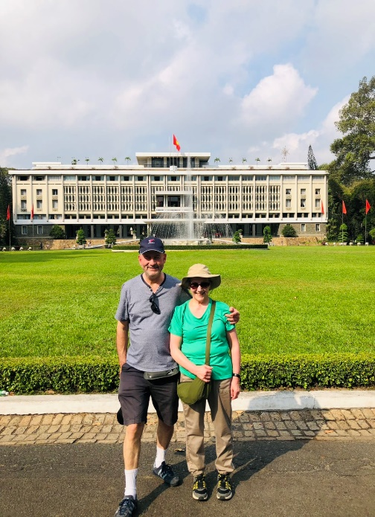
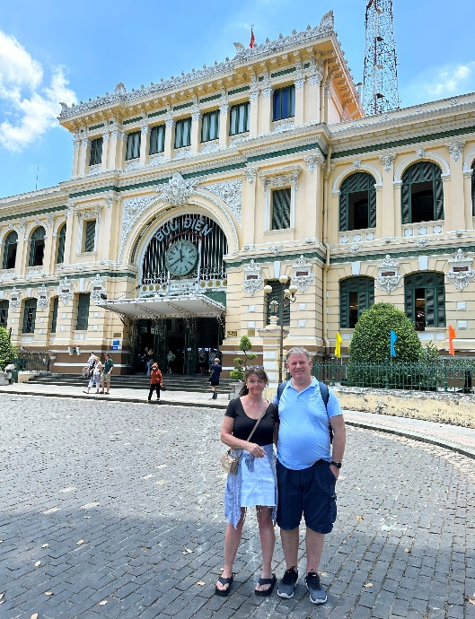
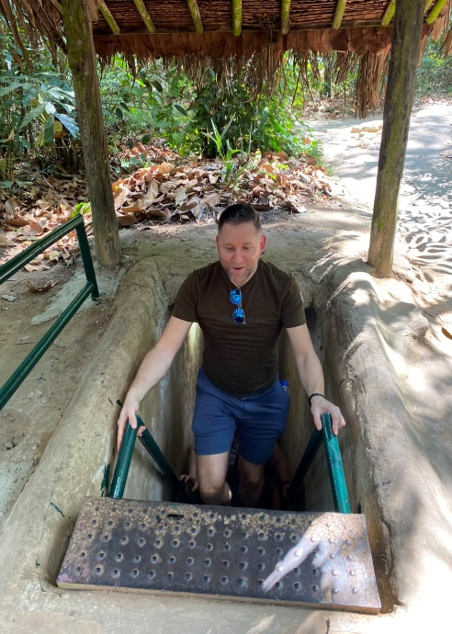

Túneles de Cu Chi Oficina Central de Correos Palacio Presidencial

After breakfast, head to Cu Chi to visit the incredible underground tunnel network built by Vietnamese guerrilla fighters during the Vietnam war. Once on the National Highway 22, drive a further 25km before we start to pedal our bikes for 30km on the slightly bumpy roads with rubber plantations and paddy fields stretching towards the horizon. Return to Saigon by van on another route. Back to Saigon Despite the well-documented hustle and bustle, the city retains its connections to the past. Embark on a walking tour to admire Saigon’s historic landmarks including a stroll down Rue Catinat of Graham Greene's 'The Quiet American', which reveals several colonial classics; the Opera House, a three-story classical theatre built to entertain the French colonists (outdoor visit); the former Hotel de Ville constructed for the French bureaucrats of Indochina in 1901, now The People's Committee building with no public access; the Notre Dame Cathedral, a stunningly massive red-brick edifice with twin spires, a clear reminder that French once ruled this city (open only 3-4pm every day, otherwise just an outdoor visit); the Central Post Office influenced by Renaissance architecture; and the former Presidential Palace, headquarters of the Saigon Government during the American war.
Overnight at hotel in Saigon.

Día 2: Visita de la ciudad de Ho Chi Minh – Túneles de Cu Chi (D/A/C)
Después del desayuno, salida hacia Cu Chi para visitar la increíble red de túneles subterráneos construidos por los guerrilleros vietnamitas durante la guerra de Vietnam. Una vez en la Carretera Nacional 22, continuamos otros 25 km antes de comenzar a pedalear durante 30 km por carreteras ligeramente irregulares, con plantaciones de caucho y campos de arroz extendiéndose hasta el horizonte.
Regreso a Saigón en furgoneta por una ruta diferente. A pesar del conocido bullicio, la ciudad conserva fuertes vínculos con su pasado. Inicio de un recorrido a pie para admirar los principales monumentos históricos de Saigón, incluyendo un paseo por la Rue Catinat de la novela El americano impasible de Graham Greene, donde se revelan varios ejemplos clásicos de la arquitectura colonial: la Ópera, un teatro clásico de tres plantas construido para entretener a los colonos franceses (visita exterior); el antiguo Hotel de Ville, construido para los burócratas franceses de Indochina en 1901, hoy edificio del Comité Popular (sin acceso al público); la Catedral de Notre Dame, un imponente edificio de ladrillo rojo con dos torres, claro recordatorio del dominio francés (abierta solo de 15:00 a 16:00; fuera de ese horario, visita exterior); la Oficina Central de Correos, influenciada por la arquitectura renacentista; y el antiguo Palacio Presidencial, sede del gobierno de Saigón durante la guerra estadounidense.
Noche en Saigón.

Day 3: Saigon - Dalat (Elevation gaining 500 to 1500 meters) (B/L/D)
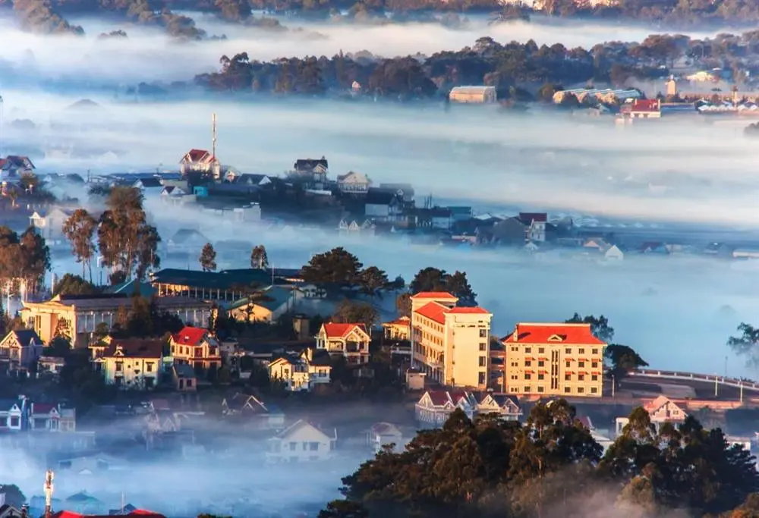
Leave Saigon after breakfast for Dalat. We take Highway 1 to Suoi Tien recreational park to start pedal power towards Dalat, passing Bao Loc pass and mulberry farms. We take a short break at La Nga Lake to see the floating houses, Di Linh tea plantation and Lien Khuong Waterfall. A highland haven dotted with lakes, waterfalls, pine forests and gardens, Dalat is Vietnam’s premier honeymoon spot. Established as a hill station at the beginning of the century, Dalat, located on the Lang Biang Plateau with its French chalets, varieties of orchids and fresh vegetables, is reminiscent of an alpine town. The town suffered little from the years of war and its colonial houses have lost none of their charm. On arrival in Dalat around 5.30pm, check in at your hotel.
Panorama de Da Lat
Overnight at hotel in Dalat.
Cycling distance: Approximately 30 - 60km

Día 3: Saigón – Da Lat (ganancia de altitud de 500 a 1.500 metros) (D/A/C)
Salida de Saigón después del desayuno hacia Dalat. Tomamos la Carretera Nacional 1 hasta el parque recreativo Suoi Tien para comenzar el recorrido en bicicleta rumbo a Dalat, pasando por el paso Bao Loc y plantaciones de moreras. Realizamos una breve parada en el lago La Nga para observar las casas flotantes, las plantaciones de té de Di Linh y la cascada de Lien Khuong.
Refugio de las tierras altas salpicado de lagos, cascadas, bosques de pinos y jardines, Dalat es el principal destino de luna de miel de Vietnam. Establecida como estación de montaña a principios del siglo pasado, Dalat, situada en la meseta de Lang Biang con sus chalets franceses, variedades de orquídeas y verduras frescas, recuerda a una ciudad alpina. La ciudad sufrió poco durante los años de guerra y sus casas coloniales no han perdido su encanto.
Llegada a Dalat alrededor de las 17:30, check-in en el hotel.
Noche en Da Lat.
Distancia en bicicleta: 30–60 km

Day 4: Dalat - Loop 25 kilometers (B/L/D)
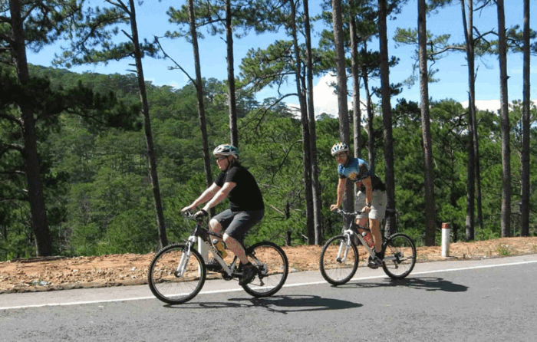
Heading out through the old streets of Dalat, we pass several historical French villas along a pine tree-lined road and sweeping views of the town below. Pedal past several lakes, the Valley of Love, the city cemetery, Lam Ty Ni Pagoda, Bao Dai’s summer palace and Pasteur Institute before returning to the hotel.
A walking tour around the center of this small town features in the late afternoon.
Overnight at hotel in Dalat.
Cycling distance: Approximately 20 - 40km
Paseo en bicicleta en Da Lat

Día 4: Dalat – Ruta circular 25 km (D/A/C)
Salida en bicicleta por las antiguas calles de Dalat, pasando por varias villas francesas históricas a lo largo de una carretera bordeada de pinos y con amplias vistas de la ciudad. Recorrido en bicicleta junto a varios lagos, el Valle del Amor, el cementerio de la ciudad, la pagoda Lam Ty Ni, el palacio de verano de Bao Dai y el Instituto Pasteur, antes de regresar al hotel.
Por la tarde, recorrido a pie por el centro de esta pequeña ciudad.
Noche en Dalat.
Distancia en bicicleta: 20–40 km

Day 5: Dalat - Phan Rang (B/L/D)
Playa de Phan Rang
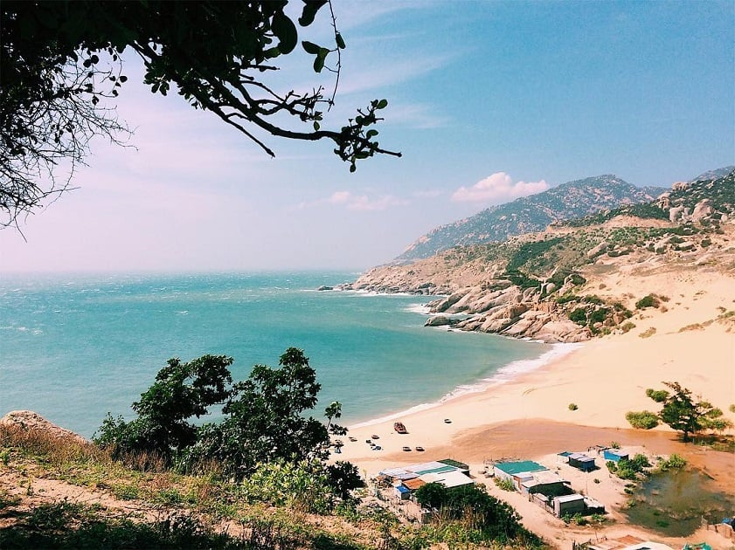
Leave Dalat for Phan Rang. The initial bumpy distance will be covered by bike before climbing Ngoan Muc Pass for photo opportunities. After going down the beautiful descent, we bike along paved roads for 60km to Phan Rang with views of coastline and white sand beaches. We will also visit the most beautiful Cham Tower in the country, built in the 13th century. On arrival in Phan Rang, check into the hotel.
Overnight at hotel in Phan Rang (B/L/D)
Cycling distance: Approximately 30 - 60km

Día 5: Dalat – Phan Rang (D/A/C)
Salida de Dalat hacia Phan Rang. El primer tramo, más irregular, se realiza en bicicleta antes de ascender el paso Ngoan Muc para realizar paradas fotográficas. Tras descender por una hermosa bajada, continuamos en bicicleta por carreteras asfaltadas durante 60 km hasta Phan Rang, con vistas de la costa y playas de arena blanca.
Visita a la torre Cham más hermosa del país, construida en el siglo XIII. Llegada a Phan Rang y registro en el hotel.
Noche en Phan Rang.
Distancia en bicicleta: 30–60 km

Day 6: Phan Rang - Nha Trang (B/L/D)
Leave Phan Rang in the morning for a drive to Nha Trang. After Phan Rang Highway One, we turn north and follow the coast past salt ponds and vivid green paddy fields to Nha Trang. Check into the hotel on arrival.
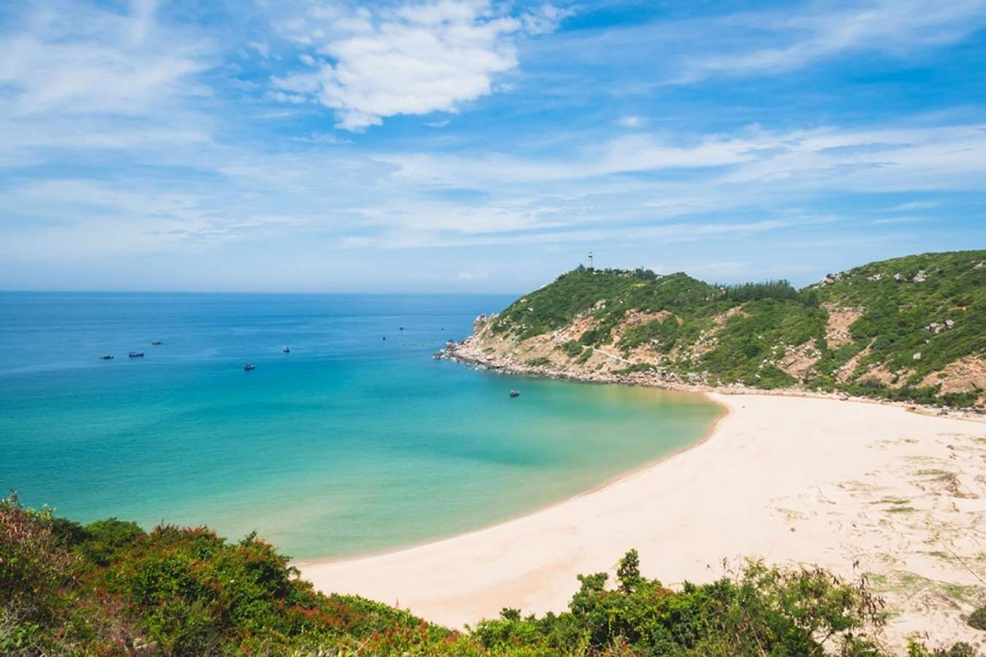
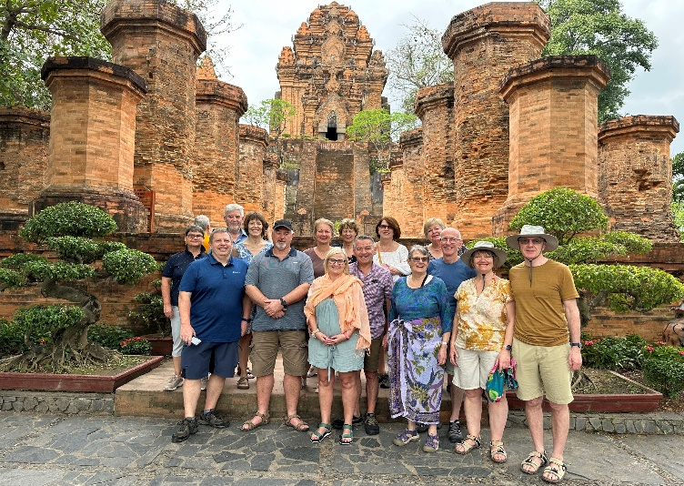
Torres de Po Nagar Cham Playa de Nha Trang
Embark on half-day city tour on the bike in the afternoon to visit Po Nagar Cham towers and Hon Chong, before returning via small countryside roads. Back to hotel for the night.
Overnight at hotel in Nha Trang (B/L/D)
Cycling distance: Approximately 30 - 60km

Día 6: Phan Rang – Nha Trang (D/A/C)
Salida de Phan Rang por la mañana en dirección a Nha Trang. Después de la Carretera Nacional 1, giramos hacia el norte y seguimos la costa, pasando por salinas y campos de arroz de un verde intenso hasta llegar a Nha Trang. Registro en el hotel a la llegada.
Por la tarde, recorrido en bicicleta de medio día por la ciudad para visitar las torres Cham de Po Nagar y Hon Chong, regresando por pequeños caminos rurales.
Noche en Nha Trang.
Distancia en bicicleta: 30–60 km

Day 7: Nha Trang (B/L/D)
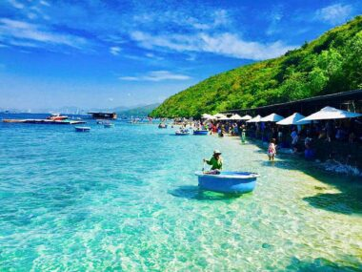
A morning cruise on the turquoise waters to visit offshore islands of Nha Trang bay as well as Tru Beach and Con Se Tre islands.
There are opportunities to swim and snorkel. After a seafood lunch return to shore, with the rest of the day free to explore the city or relax under a coconut palm on the sandy beach
Overnight at hotel in Nha Trang.
Cycling distance: Approximately 30 - 60km

Isla de Con Se Tre
Día 7: Nha Trang (D/A/C)
Crucero matutino por las aguas turquesas para visitar las islas cercanas de la bahía de Nha Trang, así como la playa Tru y la isla Con Se Tre.
Habrá oportunidades para nadar y practicar snorkel. Después de un almuerzo de mariscos, regreso a tierra. El resto del día queda libre para explorar la ciudad o relajarse bajo una palmera en la playa de arena.
Noche en Nha Trang.
Distancia en bicicleta: 30–60 km

Day 8: Nha Trang - Loop 40 kilometers (B/L/-)
We take a bike ride from your hotel towards the west of the city to Dien Khanh, where we visit the Dien Khanh Old Citadel circa 18th century, before continuing to Khanh Vinh valley over a spectacular pass. On the way back, turn off to Suoi Tien spring for a rest. Afterwards, we take the National Highway 1 to ride back to the hotel in Nha Trang.
End of services or continue with beach holidays
- Important notes:
- This is an off beaten track walk, which is very good for clients who wish to get away from crowds at touristic places.
- What to bring: Good trekking boots, rainwear, 2 sets of clothes, socks, towel, swimming suit, Camera and film, flash light, Medicine for personal use.
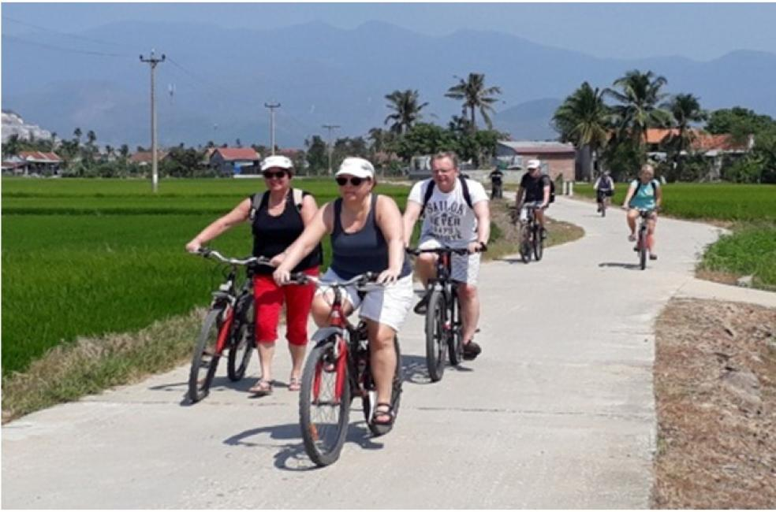
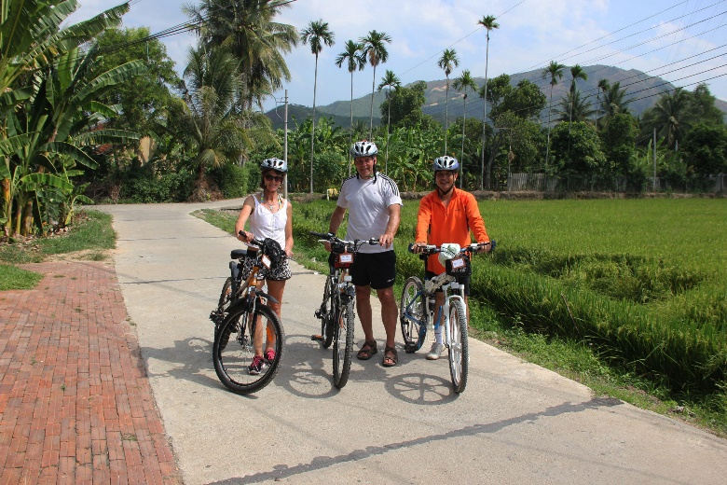
- Normally, the trekking distance is about 5- 20 km per day. And biking distance is from 20 – 60 km. Depend on your healthy, our itinerary can be flexible to meet your ideas during the trip
Paseo en bicicleta

End of services

Día 8: Nha Trang – Ruta circular 40 km (D/-/-)
Salida en bicicleta desde el hotel hacia el oeste de la ciudad, rumbo a Dien Khanh, donde se visita la antigua ciudadela de Dien Khanh, del siglo XVIII, antes de continuar hacia el valle de Khanh Vinh a través de un paso espectacular. En el camino de regreso, desvío hacia el manantial Suoi Tien para un descanso. Luego, tomamos la Carretera Nacional 1 para regresar en bicicleta al hotel en Nha Trang.
Fin de los servicios o continuación con vacaciones de playa.
Notas importantes:
- Este es un itinerario fuera de los circuitos habituales, ideal para clientes que desean alejarse de las multitudes en lugares turísticos.
- Qué llevar: buenas botas de trekking, impermeable, dos mudas de ropa, calcetines, toalla, traje de baño, cámara y película, linterna y medicamentos de uso personal.
- Normalmente, la distancia diaria de trekking es de 5 a 20 km y la distancia en bicicleta varía entre 20 y 60 km. Dependiendo de su condición física, el itinerario puede adaptarse de forma flexible durante el viaje.
Fin de servicios

List of accommodations
Lista de alojamientos
Location  Ubicación | 4* hotel | 5* hotel
Ho Chi Minh | Kin, Paragon, Northen Charm* * * * (ROH) | New World, Pullman* * * * * (Deluxe)
Lam Dong | TTC Ngoc Lan, Muong Thanh Holiday* * * * (Deluxe) | Ana Mandara, Dalat Palace * * * * * (Superior)
Phan Rang | TTC Phan Giang * * * * (Superior)
Khanh Hoa | Liberty Nhatrang* * * * (Deluxe) | Queen Ann * * * * * (Deluxe)

Rates and Conditions
Prices are in USD per person, based on two guests sharing a twin or double room in the hotels mentioned above.
Below rates are not valid for the period of Christmas, New Year (normally from 20 Dec to 10/ 15 Jan), Vietnamese New Year (16 Feb – 26 Feb ), Independence Day (30 April), May Day, National Day (02 Sep), etc. Please contact us for further details in terms of specific dates.
Tarifas y condiciones
Los precios están expresados ​​en dólares estadounidenses por persona, en base a dos huéspedes compartiendo habitación doble o twin en los hoteles mencionados.
Las tarifas a continuación no son válidas para Navidad, Año Nuevo (normalmente del 20 de diciembre al 10/15 de enero), Año Nuevo chino/vietnamita, Día de la Independencia (30 de abril), Primero de Mayo, Día Nacional (2 de septiembre), entre otros. Para más información sobre fechas específicas, contáctenos.

High Season 01 Jan 2026 – 30 Apr 2026 and 01 Oct 2026 - 31 Dec 2026

Temporada alta 2026
01 de enero de 2026 – 30 de abril de 20276 y 01 de octubre de 2026 – 31 de diciembre de 2026
Group size/ Price per person | 2 | 3 | 4 | 5 | 6 | SGL supplement
4* | 1,920 | 1,510 | 1,304 | 1,179 | 1,097 | 271
5* | 2,158 | 1,750 | 1,546 | 1,424 | 1,342 | 498
Low Season 01 May 2026 - 30 Sep 2026

Temporada baja 2026
1 de mayo de 2026 - 30 de septiembre de 2026
Group size/ Price per person | 2 | 3 | 4 | 5 | 6 | SGL supplement
4* | 1,913 | 1,501 | 1,296 | 1,172 | 1,090 | 264
5* | 2,132 | 1,725 | 1,519 | 1,397 | 1,315 | 475

Inclusions | Exclusions
  • Accommodation in the category chosen or similar (subject to availability)
  • Meals as mentioned in the program. B= Breakfast, L=Lunch, D=Dinner
  • Transfer from and to the airports by private vehicle with A/C. Transportation by private vehicle with A/C.
  • Snack, water, milk,fruits
  • All entrance fees and sightseeing as mentioned in the program.
  • Local English speaking guide(s) as mentioned
  • Early check in and late check out
  • Meals and drinks which are not mentioned in the program
  • International flight tickets and airport taxes. All internal/ regional flight tickets in economy class
  • Visa fees upon arrival in Vietnam
  • Tips & personal expenses. Personal insurance. Any services not clearly mentioned in the program.
  • TIPPING for local guide and van driver
  * 1 pax: 15 USD/ pax/ day
  * 2 - 4 pax: 10 USD/ pax/ day
  * 5 pax: 6 USD/ pax/ day
  *Suggested TIPPING for bellboy, boat crew, sampan driver: depend on your satisfication.

Incluidos | Excluidos
• Alojamiento en la categoría elegida o similar (sujeto a disponibilidad)  • Comidas según lo mencionado en el programa: D=  Desayuno, A= Almuerzo, C= Cena, basadas en comida vietnamita.  • Traslados desde y hacia los aeropuertos en vehículo privado con aire acondicionado. Transporte terrestre en vehículo privado con aire acondicionado.  • Snack, agua, leche, frutas.  • Entradas y visitas turísticas según lo mencionado en el programa  • Guía(s) local(es) de habla inglesa según lo mencionado. | • Check-in temprano y check-out tardío  • Comidas y bebidas no mencionadas en el programa  • Billetes de vuelos internacionales y tasas aeroportuarias. Todos los vuelos internos/regionales en clase económica.  • Tasas de visado a la llegada a Vietnam.  • Propinas y gastos personales. Seguro personal. Cualquier servicio no mencionado claramente en el programa.  • PROPINAS para el guía local y el conductor de la  furgoneta  * 1 persona: 15 USD cada persona por día  * 2-4 personas: 10 USD cada persona por día  * A partir de 5 personas: 6 USD cada persona por día  *Propinas sugeridas para botones, tripulación del  barco y conductor del sampán: según su satisfacción

GENERAL TERMS & CONDITIONS
Remarks for check in and check out schedules
Check in time: at hotel: after 14h00
Check out time: at hotel before 12h00.
Remarks for itinerary
The itinerary and schedule are subject to change due to local traffic situations, weather conditions; flight, or any un-foreseen circumstances or local authority decision. LV Travel reserves full rights to replace all items with same values for guests.
Remarks for meal
Meals are fusion on local food with daily normal buffet breakfast at hotel. Guests should advise any special food preferences, allergies or dietary requirements at least one (1) week prior to the arrival date.
Remarks for the price
16 full paying pax group is granted one FOC based on half twin sharing room (exclusive of extra service).
Please be aware that any changes in the itinerary due to unforeseen circumstances might result in increase in pricing.
Any damage caused to all services during the stay shall be payable by the passengers.
Validity
All prices quoted to the Client/Agent are on a net basis in United States Dollars and valid according to the date specified on the LV Travel printed tariffs and/or quotation and/or invoice issued to the Client/Agent. LV Travel warrants that the prices or rates quoted to the Client/Agent are correct at the time of issuance or invoice but are subject to change in line with market, tax or currency fluctuation, with or without prior notice.
Payment method
Unless otherwise agreed by LV Travel, client’s payment shall be executed by bank transfer, to the LV travel’s bank account clearly noted in all the invoices. Every party shall take care of the transfer fees occurring with its relevant bank.
Payment conditions for domestic or international flights : We will check case by case.
Payment conditions for land tour without flights:
- In general there is no Deposit required. LV Travel reserves its right to forward deposit requests from suppliers in case they occur.
- The full payment of 100% of the total price must be transferred to the LV Travel account 30 days prior to the group arrival in Indochina, if not agreed otherwise.
Cancellation of domestic or international flights: We will check case by case.
Cancellation policy for land tour without flights:
- All cancellations should be made in writing and should be acknowledged by LV travel.
-Cancellation Rules for Land Tour, not apply for domestic or international flights (if any).
- Cancellation more than 45 days prior to the group arrival: No Charge. Deposit shall be deducted into the next bookings, except specified suppliers require cancellation fees.
- Cancellation between the 45th and 31st day prior to the group arrival: 25% of the total tour price.
- Cancellation between the 30th and 23rd day prior to the group arrival: 30% of the total tour price.
- Cancellation between the 22nd and 16th day prior to the group arrival: 40% of the total tour price.
- Cancellation between the 15nd and 09th day prior to the group arrival: 60% of the total tour price.
- Cancellation between the 08nd and 03rd day prior to the group arrival: 80% of the total tour price.
- Cancellation between the 02nd and 0th day prior to the group arrival: 100% of the total tour price.
- In case the tour participant(s) shorten or interrupt the tour of their own accord there will be no reimbursements.
- Reduction in the number of passengers against requested bookings is considered and treated as cancellations.
- If the balance of the tour invoice is not received by the deadline of 15days prior to the group arrival, LV Travel will reserve the right to cancel the reservation without indemnity or any reimbursement.
- If LV Travel is forced to cancel the departure due to unforeseeable reasons, the participants will be fully reimbursed without intention to claim for any indemnities.
Contact details
Hotline for sales (ms Moon) | +84 888 905 286 (WA/viber/mobile)
Hotline for operation (ms Anna Hanh) | +84 983 096 032(WA/viber/mobile)
General Manager Mr Len | +84 989 200 116 (WA/viber/mobile)

TÉRMINOS Y CONDICIONES GENERALES

Información sobre los horarios de entrada y salida
Hora de entrada: en el hotel: después de las 14:00 h - en el crucero: antes de las 12:00 h.
Hora de salida: en el hotel y en el crucero: antes de las 12:00 h.

Información sobre el itinerario
El itinerario y el horario están sujetos a cambios debido a la situación del tráfico local, las condiciones meteorológicas, el vuelo, cualquier circunstancia imprevista o decisión de las autoridades locales. LV Travel se reserva el derecho de reemplazar todos los artículos por el mismo precio para los huéspedes.

Información sobre las comidas
Las comidas son una fusión de platos locales con desayuno buffet diario en el hotel. Los huéspedes deben informar sobre cualquier preferencia alimentaria, alergia o requisito dietético especial con al menos una (1) semana de antelación a la fecha de llegada.

Información sobre el precio
A los grupos de 16 personas que pagan la tarifa completa se les otorga una habitación compartida (sin incluir servicios adicionales).
Tenga en cuenta que cualquier cambio en el itinerario debido a circunstancias imprevistas podría resultar en un aumento de precios.
Cualquier daño causado a los servicios durante la estancia será responsabilidad de los pasajeros.

Validez
Todos los precios cotizados al Cliente/Agente son netos en dólares estadounidenses y válidos según la fecha especificada en las tarifas impresas de LV Travel, la cotización o la factura emitida al Cliente/Agente. LV Travel garantiza que los precios o tarifas cotizadas al Cliente/Agente son correctos al momento de la emisión de la factura, pero están sujetos a cambios según las fluctuaciones del mercado, los impuestos o la moneda, con o sin previo aviso.

Método de pago
Salvo acuerdo en contrario con LV Travel, el pago del cliente se realizará mediante transferencia bancaria a la cuenta bancaria de LV Travel claramente indicada en todas las facturas. Cada parte se hará cargo de los gastos de transferencia con su banco correspondiente.

Condiciones de pago para vuelos nacionales o internacionales: Se revisará cada caso individualmente.
Condiciones de pago para tours terrestres sin vuelos:
- Generalmente, no se requiere depósito. LV Travel se reserva el derecho de reenviar las solicitudes de
depósito de los proveedores en caso de que se produzcan.
- El pago completo del 100% del precio total debe transferirse a la cuenta de LV Travel 30 días antes de la llegada del grupo a Indochina, salvo acuerdo en contrario.
Cancelación de vuelos nacionales o internacionales: Se revisará cada caso individualmente.
Política de cancelación para tours terrestres sin vuelos
- Todas las cancelaciones deben realizarse por escrito y LV Travel debe confirmar su recepción.
- Las normas de cancelación para tours terrestres no aplican para vuelos nacionales o internacionales (si los hubiera).
- Cancelación con más de 45 días de antelación a la llegada del grupo: Sin cargo. El depósito se descontará de las siguientes reservas, excepto en el caso de proveedores específicos que requieran cargos por cancelación.
- Cancelación entre el 45 y el 31 días antes de la llegada del grupo: 25% del precio total del tour.
- Cancelación entre el 30 y el 23 días antes de la llegada del grupo: 30% del precio total del tour.
- Cancelación entre el 22 y el 16 días antes de la llegada del grupo: 40% del precio total del tour.
- Cancelación entre el 15 y el 9 días antes de la llegada del grupo: 60% del precio total del tour.
- Cancelación entre el 8 y el 3 días antes de la llegada del grupo: 80% del precio total del tour.
- Cancelación entre el 2 y el 0 días antes de la llegada del grupo: 100% del precio total del tour.

- En caso de que el/los participante(s) del tour acorten o interrumpan el tour por decisión propia, no se realizarán reembolsos. - La reducción del número de pasajeros respecto a las reservas solicitadas se considera una cancelación.
- Si el saldo de la factura del tour no se recibe dentro de los 15 días previos a la llegada del grupo, LV Travel se reserva el derecho de cancelar la reserva sin indemnización ni reembolso alguno.
- Si LV Travel se ve obligado a cancelar la salida por causas imprevistas, los participantes recibirán un reembolso completo sin derecho a reclamar indemnización alguna.

Contacto detallado
Línea directa de ventas (Sra. Moon) | +84 888 905 286 (WA/Viber/móvil)
Línea directa de operaciones (Sra. Anna Hanh) | +84 983 096 032(WA/viber/ móvil)
Gerente general, Sr. Len | +84 989 200 116 (WA/viber/ móvil)

